To: Orchestra Parents and Students
From: Mrs. Gigax, 5th Grade Strings

We are off to a great start! At this point, students are able to turn the D string into E, F#, and G by pressing with left hand fingertips. Also, we are taking command of the bow, using a relaxed and flexible grip with the stick balancing on the right thumb tip. Please use the pictures below, along with diagrams in the Essential Elements book (like on page 6), for a good reference. Be patient, and take your time with the details of proper technique. Look for things like curved fingers and naturally straight left wrists.
One thing that makes it fun to practice is the CD that comes in the Essential Elements book. It has the background accompaniments to lots of exercises. It even provides SmartMusic, an interactive software option that can be loaded onto your computer to show where correct and incorrect pitches are being played. It can’t see your bow hold and posture, but it can hear notes if your desktop or laptop has a microphone (one can be purchased and plugged in if necessary). I have made an instructional video to help you get started – students should ask permission before going on the internet:
http://www.youtube.com/watch?v=MMrQLstHW0w
Note: The Hal Leonard Publishing site is also a good resource if you are having trouble downloading SmartMusic with the CD.
Please look for a fundraising brochure from Peterson Nuts. OPUS, which is the orchestra parents’ society, has done a lot for orchestra students of all levels in Brunswick, and can use your support. This fundraiser is not required, but all profits go directly to the orchestra program. All money should be turned in mid-October.
Thank you!

Violin/Viola Cello/Bass
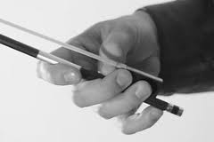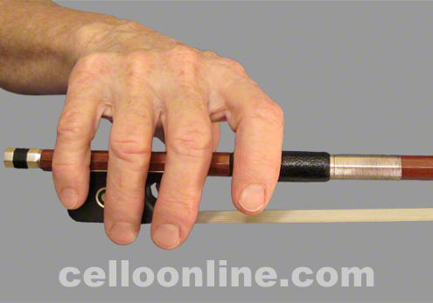
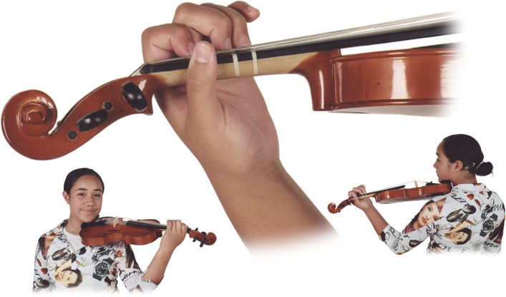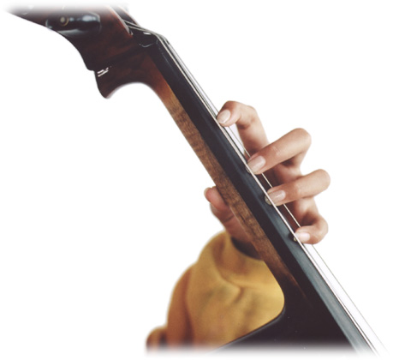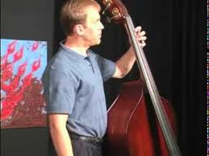
Violin/Viola Cello Bass

